13 April 2007 The Weekly Bulletin of Rotary Club of Kathmandu Mid-Town Bc # 41 of 2006-07
Rotary Club of Kathmandu Mid-Town
Breakfast Chatter




District : 3290 Web: www.rotarymidtown.org.np Club Id : 26776

APRIL IS THE MAGAZINE MONTH
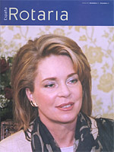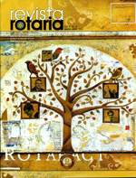
The Rotarian and the other magazines, known collectively as the Rotary World Magazine Press, are a wonderful source of information.

Dr Lynn Bennett provided an interesting talk on "Social Exclusion in Nepal"
at the Club meeting on 6 April 2007
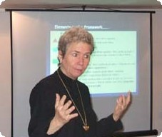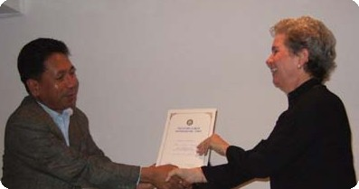
Guest Speaker Dr Bennett talking to Club members while giving her presentation;
Acting President Subarna Joshi shaking hand with the Speaker after handing over a Certificate of Appreciation for her presentation.

Weekly Meetings and Programs :
Date | Program/Speaker | Program/Topics of Presentation
13 April 2007 | No meeting | Happy New Year 2064 holiday
20 April 2007 | Club assembly | Club assembly (5)
27 April 2007 | Mangal Man Shakya | Illegal wildlife trade
4 May 2007

Friday, 13 April :
To celebrate Happy New Year 2064, the Rotary Club of Kathmandu Mid-Town will be observing holiday on Friday, 13 April (30 Chaitra 2063, the last day of the Nepali Calendar). There will be no weekly meeting on Friday, 13 April 2007. Well, you have an extra hour to sleep ! Enjoy !!

Congratulations to PP Dr Chandra Lekha Tuladhar :
United Nations Women's Organization (UNWO) in Nepal felicitated Dr Chandra Lekha Tuladhar on 8 March, International Women's Day for her immense contributions in improving the health of disadvantaged and less fortunate.
   Congratulations   

Happy New Year 2064 :
On the occasion of Happy New Year 2064 the Breakfast Chatter editor sends best Greetings to
all Mid-Towners, their spouses, children and all other family members.
Happy New Year
2064

Council on Legislation to consider Standing Committee on Population Concerns :
Late in the week of 22-27 April 2007 in Chicago, Illinois, Rotary’s triennial Council on Legislation will consider an Enactment to add Population Concerns to the list of seven other Standing Committees that Rotary is required to have on a continuing basis. It will be the second time Population Concerns will have been considered by the Council. In 1998, the Council passed almost unanimously, a Resolution declaring that Rotary should include Population Concerns as one of its humanitarian programs. Unfortunately, in the eight years since that decision, Rotary leadership has been alternatingly hot and cold on the issue, even intentionally ignoring it on a few occasions. If the Enactment is passed, the RI Population Concerns Committee will stand, in spite of the occasional changing attitudes of leadership.

On Lighter Side : Click at the figure ⇩


Our environment is literally what surrounds us: the air we breathe, the water we drink, the land we walk on. Our environment is our house, our yard, our street. It is our community, our country, and our planet.
RI President William B. Boyd

13 April 2007 The Weekly Bulletin of Rotary Club of Kathmandu Mid-Town Bc # 41 of 2006-07

Editor: RR Shrestha, Club Service Director email: rryes@wlink.com.np

